Report plan
Research question – how does spending on security equipment differ between demographics and households
Abstract – must be 200 words – more straight forward focus mainly on the results of the analysis or key variables and how it meets the hypothesis and what conclusion this brings you to (200 words)
Introduction – introduce the research question the hypothesis for the research question alongside background readings laying out the structure. (250 words)
Data – talk more in depth about the data sets and chosen variables why they were picked methodology. Then produce two tables or graphs for ealry exploratory analysis to set up the cluster or association rules analysis. for each diagram include a stub or long description (300 words)
Results – the results of the cluster or a rues analysis what this means for the hypothesis what can the findings tell us. Alongside graphs tables and charts of the analysis (400 words)
Limitations – the limitations of the analysis how can it be improved upon (150 words)
Conclusions – summarise the findings and limitations explain how this topic can be expanded and by future researchers in a more indepth study (200 words)
Report should be targeted at market analysts with a maximum of 5 diagrams
Word count does not include title tables figures or refferences

Code plan
Variables to include
cctv expenditure, - 773
rural urban, - rual – 1 urban-2
religion – 1 – hindu 2 – muslim 3 – Christian 4- sikh – 5 -jainism 6- bhuddism Zoroastrianism 7 others – 9
household size, - b3q1
occupation,
social group, - tribes = -1 castes -2 backward cllases -3 other-9
sex – male 1 female 2
MPCE – total houshehold expenditure divided by number in the household
monthly consumer expenditure,
expenditure on IT equipment, - 789
expenditure on communication technology - 589
clustered based on
cctv expenditure main
- rurual urban – a773
- religion – relig
- household size – b3q1
- sex – male
- age – age
- MPCE – mpce

Begin introduction outlien the stated research question and my hypothesis for how this will turn out. Use the sources form the ladt assignment also find some new ones or more information form the previous sources. Then explain the outlien of the essay start with a descriptive statistics table to show the jey infor about variables I can then also talk about each indiivual variable and what the numbers mean. Talk about why I chose clustering and why I have chosen k means clustering
I will then produce a corrwlation matrix I will find only very minor correlation between most of the variables however some do have very small positive and negative correlations. I am going to go ahead with the cluster analysis to see if the combination of these demographics have any significant effect
We use mean for a segement summary instead of median because we have some binary variables (chaman and feit shown in seg sum factor)
how does spending on security equipment differ between demographics and households
Hypothesis – larger wealthy urban male dominated older households will have the most security expenditure

11430495
How does spending on CCTV security equipment vary across marketing segments in India?
Word count -
Abstract
This report analyses the variations in spending on CCTV equipment among market segments in India using 2016 national household expenditure survey data. This was carried out through the use of a K-means cluster analysis on key variables such as, CCTV expenditure, rurality, household size, MPCE, sex, religion and age. The cluster analysis showed that urbanisation was the main driving force behind CCTV expenditure. However increased household size was associated with limited CCTV expenditure. Whereas age, religion and sex had limited influence. Therefore, my hypothesis that large wealthy urban families being the primary customer demographics behind CCTV expenditure was only partially correct. These findings alongside limitations of this report lead me to call for further research into this topic using more up to date data and a localised analysis.

Introduction
Throughout this report I will be answering the question, “How does spending on CCTV security equipment vary across marketing segments in India?”. I will answer this question by carrying out a K-means cluster analysis on 2016 Indian household expenditure survey data. My chosen variables for this analysis are CCTV expenditure, mean per capita expenditure (MPCE), household size, rurality, sex, religion and age. I have chosen these variables as I believe they will provide a broad insight into the driving factors of CCTV expenditure. For example, Anand (2023) finds that there are large wealth disparities between India’s demographic groups particularly between urban and rural demographics. Yet 12% of the world’s population resides in the Indian rural market (Parida and Sahney 2017) emphasising the broad scope and importance of this demographic for marketing research. Furthermore Baber (2019) outlines the important role religion plays in consumer behaviour influencing behavioural responses to advertisement and consumer satisfaction. Mean per capita expenditure and household size may also play an important role influencing CCTV expenditure as the increased size of a household may increase the need for CCTV itself while MPCE can show a household’s capability to spend on CCTV at all. Therefore, I hypothesise that large wealthy urban families will be the primary customer demographics for CCTV expenditure. This report will begin with a preliminary data analysis describing the key variables and measuring their correlation to one another. It will then progress into the cluster analysis and discussion of the results. I will conclude this paper with a discussion of its limitations.

Preliminary data analysis
Table 1
 | n | mean | sd | min | max | range | se
CCTV | 158165 | 16.88 | 441.16 | 0 | 38000 | 38000 | 1.1093
rural | 158165 | 1.45 | 0.5 | 1 | 2 | 1 | 0.0013
sex | 158165 | 1.49 | 0.5 | 1 | 2 | 1 | 0.0013
relig | 158165 | 1.24 | 0.43 | 1 | 2 | 1 | 0.0011
age | 158165 | 38.60 | 14.9 | 18 | 120 | 102 | 0.0375
HHsize | 158165 | 5.85 | 2.91 | 1 | 40 | 39 | 0.0073
mpce | 158165 | 2354.44 | 3055.73 | 0 | 306666.7 | 306666.7 | 7.6835
National sample survey office (2016)
Table 1 displays a descriptive statistics table for my chosen variables highlighting key information about each variable. Each variable Is made up off 158165 observations with the mean, SD, min, max, range and SE displayed. While each variable is numerical rural, sex and religion are binary with means of 1.45, 1.49 and 1.24 respectively. CCTV, age, household size and MPCE are continuous with means of 16.88, 38.6, 5.85 and 2354.44.
The binary variable religion was recoded grouping categories into Hinduism (1) and other (2). This was done as other religions combined only make up 24% of the total population. by combining them they have become a more substantial category. This may allow for an improved comparison between Hindus and other religious groups identifying whether significant differences in market preferences exist between Hindus and non-Hindus.
A key statistic highlighted by the table is the standard deviation of MPCE being 3055.73 being substantially higher than the mean. This implies that there is a large variation and gap between households in their per person expenditure. This further supports Annand’s (2003) findings of large wealth disparities in India.

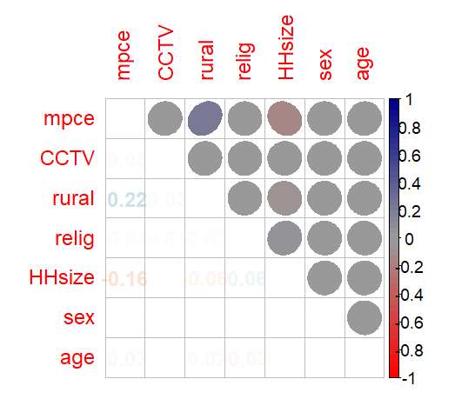
Figure 1

National sample survey office (2016)
Figure 1 displays a correlation heat map between each of my chosen variables. Most variables display little to no correlation with one another. However, the variables MPCE and Household size do display weak correlations among variables. For example, MPCE is shown to have a weak positive correlation with urban households displaying a Pearson's r coefficient of 0.22. This further supports Annand’s (2003) observation of significant disparities between urban and rural populations especially in comparison to other demographics. Another weak correlation associated with MPCE is between household size which displays a negative correlation of 0.16. This suggests that the more members of a household the less money they are likely to expend. However, this does not necessarily mean that larger families are more likely to be poor. Rather MPCE is a measure of average household spending per person therefore families with multiple children will have their average brought down more than childless couples and individuals. Overall preliminary correlation analysis has revealed only weak relationships between the key variables. However, some associations do still remain, and cluster analysis may be able to form grouping based on these.
Cluster analysis
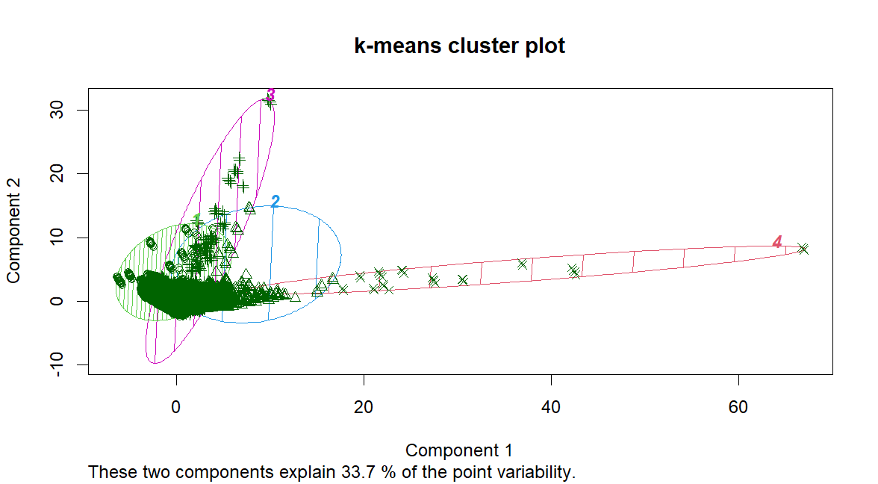
figure 2

National sample survey office (2016)
Figure 2 displays the K-means cluster plot of my chosen variables. According to Chapman and Feit (2019) this is an unsupervised model which attempts to find clusters and groupings from the structure of the data itself. K-means is a distance method of clustering which models data in centroid clusters. This attempts to maximize the distance between groups and minimise the distance within the group itself creating distinct entities with unique attributes (Chapman and Feit 2019).
Figure 2 is a highly dense plot with many observations between 0 and 10 on the x axis and 0 and 5 on the y axis. However, it does also display a large amount of variance and outliers with some observations reaching 30 on the y axis and 70 on the x axis. I have then grouped these observations into 4 distinct clusters with some minor overlapping in the most dense part of the graphs.

Group.1 | CCTV | rural | sex | relig | age | HHsize | mpce
1 | 8.55 | 1.35 | 1.488 | 1.25 | 38.22 | 6.21 | 1609.40
2 | 102.62 | 1.86 | 1.484 | 1.21 | 41.00 | 3.86 | 14706.61
3 | 42.70 | 1.78 | 1.487 | 1.22 | 39.89 | 4.62 | 4238.98
4 | 0.00 | 1.62 | 1.437 | 1.34 | 38.71 | 4.18 | 143316.20
Table 2
National sample survey office (2016)
Table 2 displays the mean for each variable within each of the four clusters. Due to the number of binary variables used in this analysis we mean instead of median as this shows the proportion of each binary more clearly than a median (Chapman and Feit 2019). Our key variable CCTV expenditure varies substantially between each group with group 2 displaying the highest expenditure at 102.62 and lowest being group 4 with 0.00 expenditure on CCTV.
Group 2 the highest spending group is characterised as having the most urban population at 1.86 (86%) the smallest household size of just 3.86 on average and having the second highest income. This partly proved my hypothesis as living in urban areas does increase the rate of CCTV expenditure which could be due to a perceived risk of being a victim of crime. This is coupled with having medium to high income allowing for such expenditures. However, this disproves my hypothesis that household size would drive CCTV expenditure.
Group 4 is the lowest spending group and is characterized by having a 22% lower urban population than group 2 this further supports the claim that security spending and rurality are linked. However, this group does display extremely high income at 143316.20 the highest of all the groups. The lack of CCTV expenditure can be explained for a multitude of reasons. For one CCTV is not a product which individual households would buy regularly therefore it can be assumed that wealthy households already own CCTV systems and have not seen the need to purchase a new one. Furthermore, with such high levels of income they may live in safer neighbourhoods and be less exposed to crime than their heavily urban counterparts reducing the need for CCTV systems.
This cluster analysis has shown valuable trends within CCTV expenditure data previously unseen by correlation analysis. It has supported my hypothesis that urban households drive CCTV expenditure however it has also disproven my hypothesis that large household size will increase expenditure. Furthermore, it confirmed that some factors have little association with CCTV expenditure such as age and gender.

Limitations
However, this report is not without its limitations. One limitation is that the data was gathered in 2016 meaning the findings in this report may not be relevant to companies wishing to market their CCTV products in India. This is especially relevant as both the CCTV tech industry and India as a whole is developing rapidly leading to substantial changes in demographics and consumer opinions on CCTV products. Another limitation with this paper is that it generalises to cover India as a whole. Whereas by focusing more in depth on a single state or region more unique trends can be observed allowing for the application of niche marketing strategies for specific audiences.

Conclusion
To conclude this report has analysed Indian household survey data to examine how CCTV expenditure varied across Indian market segments using K-mean clustering. The analysis showed that urbanization is the driving factor for CCTV spending whereas spending is driven down by household family size disproving my initial hypothesis that household size would be associated with higher levels of spending. However, this report was limited by its scope and the age of data being analysed. Future studies can overcome these limitations by narrowing their research to specific regions and localities while analysing contemporary household survey data leading to unique marketing opportunities.

